FORM 2

THE PATENTS ACT, 1970 (39 of 1970)
&
THE PATENTS RULES, 2003

COMPLETE SPECIFICATION
(See Section 10; rule 13)

TRAIN ACCIDENT PREVENTION SYSTEM

S.No | Name | Address
1. | Dr.C.NANDAGOPAL | Assistant Professor, Department of ECE,  M.Kumarasamy College of Engineering,  Karur, India-639113
2. | S.PRATHIBA | UG Student,  Department of ECE, M.Kumarasamy College of Engineering,  Karur, India-639113
3. | M.PREETHI | UG Student,

Department of ECE,

M.Kumarasamy College of Engineering,
Karur, India-639113
4. | S.PRIYANKA | UG Student,  Department of ECE, M.Kumarasamy College of Engineering,  Karur, India-639113

The following specification particularly describes the invention and the manner in which it is to be performed.

TRAIN ACCIDENT PREVENTION SYSTEM

FIELD

The present invention relates to the field of railway safety engineering, embedded electronics. It specifically focuses on the development of an intelligent Train Accident Prevention System designed to detect and prevent major railway accidents such as derailments, collisions, and crashes at unmanned crossings. Modern railway networks face several challenges, including aging tracks, unpredictable obstacles, increasing train speeds, and limited human monitoring. This invention aims to address these issues by integrating sensor technology, microcontrollers, wireless communication, and automated alert mechanisms into a unified safety platform. The system utilizes ultrasonic sensors detectors to continuously monitor obstacles, and oncoming trains. The collected data is processed by a microcontroller, enabling fast decision-making and immediate response. Alerts are transmitted to train drivers and railway control centers to ensuring timely action during emergencies. By reducing dependence on manual inspection and human intervention, the system enhances operational reliability, improves safety standards, and minimizes the likelihood of railway accidents. This invention contributes significantly to the advancement of automated railway security by providing a technologically enhanced method for real-time surveillance and early hazard detection.

BACKGROUND OF THE INVENTION

- Railway transportation continues to be one of the most economical, widely used, and essential modes of transport for millions of people across the world. Despite technological advancements, railway systems still face major safety challenges due to factors such as aging infrastructure, increasing train speeds, natural obstructions, inadequate monitoring mechanisms, and human limitations. In developing nations, where railways form the backbone of transportation, accidents such as derailments, collisions, and level-crossing crashes continue to occur frequently. These incidents result in tragic loss of life, extensive financial damage, service disruption, and long-term infrastructural impact.
- Many of these accidents are caused by undetected cracks in railway tracks, obstacles that unexpectedly appear on the tracks, poor visibility conditions, malfunctioning signals, or miscommunication between trains. Traditional railway monitoring relies heavily on manual inspection, which is time-consuming, labor-intensive, and prone to human error. Track inspectors often have to cover long stretches of rail under harsh weather conditions, making timely identification of cracks or irregularities almost impossible. In addition, nighttime, fog, and remote terrains further reduce visibility, increasing the chances of accidents due to delayed detection of hazards.
- Existing safety systems such as mechanical track circuits, visual signaling, and manual patrolling have several limitations. These methods cannot provide continuous surveillance and are not capable of real-time data transmission to control rooms or train drivers. More importantly, traditional inspection and signaling systems do not offer predictive insights or automated decision-making capabilities. As a result, many accidents occur either before the hazard is identified or before a warning can reach the train operator in time.
- To address these gaps, recent years have seen attempts to integrate electronic sensors and automation into railway safety. However, many of these solutions suffer from high cost, limited detection range, complex installation, and absence of IoT-based communication. Some systems can only detect specific hazards but cannot provide complete hazard classification or reliable alerts. Others depend on heavy equipment or expensive maintenance, making them inaccessible for rural or low-budget railway networks. Hence, there remains a strong need for a low-cost, intelligent, portable, and real-time accident prevention system that can be deployed across long stretches of railway infrastructure.
- The present invention proposes a modern technological solution through the development of an intelligent Train Accident Prevention System that uses a combination of sensors, embedded hardware, and IoT communication to identify multiple hazards before they escalate into accidents. The system integrates ultrasonic sensors for obstacle detection, vibration or crack sensors for track condition monitoring, IR sensors for proximity detection, and RF/GSM modules for communication. These sensors continuously monitor track status and surroundings, enabling the system to detect even small anomalies such as minor cracks or small objects on the track. By using a microcontroller, the system processes sensor data instantly and generates appropriate alerts without requiring human intervention.
- One of the major challenges in railway safety is providing real-time information to operators. The invention overcomes this by incorporating GSM or IoT modules that transmit instant notifications to train drivers, track maintenance teams, and control centers. This ensures that hazardous conditions can be addressed immediately, preventing potential accidents. The system further supports cloud connectivity, enabling long-term data logging, remote monitoring, and trend analysis. This assists railway authorities in planning preventive maintenance and improving overall operational safety.
- Another critical problem addressed by this invention is the prevention of train-to-train collisions. Traditional signaling systems may fail during equipment malfunction or poor visibility. By utilizing RF communication modules, the system provides an additional layer of safety by enabling communication between nearby trains. This secondary communication channel helps avoid rear-end or head-on collisions, especially in high-speed or single-track rail sections.
- The invention also considers the practical challenges of installation and power management. It uses low-power components and rechargeable batteries, making it suitable for remote areas where electrical infrastructure is limited. The system is compact, easy to deploy, and requires minimal maintenance compared to sophisticated railway monitoring systems.

- Overall, the invention addresses the long-standing issues in railway safety by introducing a cost-effective, intelligent, automated, and scalable accident prevention system. By detecting hazards at an early stage and transmitting alerts immediately, the system prevents accidents, minimizes downtime, and ensures safe travel for passengers and goods. This invention thus marks a substantial advancement in railway accident prevention technology and contributes to building smarter and safer transportation networks.

OBJECTS OF THE INVENTION

1. Development of a Simple Accident Prevention System
The invention aims to develop a basic, low-cost Train Accident Prevention System using simple electronic components. The system functions through sensors and communication modules that monitor the railway track and detect hazards in real time. This provides a reliable safety mechanism without requiring advanced or expensive technologies.

2. Obstacle Detection on Railway Tracks
A major objective of the invention is to detect obstacles such as animals, vehicles, stones, or other objects on the track. Ultrasonic or infrared sensors are used to sense the presence of obstructions ahead of the train. This ensures that the system can alert the driver before the train reaches the danger zone, reducing chances of collision.

3. Prevention of Train-to-Train Collisions
The invention focuses on preventing collisions between two trains on the same track. RF transmitter and receiver modules allow communication between approaching trains, enabling them to warn each other of their presence. This acts as a secondary safety layer if visual signals or manual alerts fail.

4. Real-Time Warning Mechanism for Drivers
Another objective is to provide immediate and clear warnings to the train driver whenever a hazard is detected. The system activates a buzzer, LED indicator, or alarm signal without delay. This supports quick driver decisions such as slowing down or stopping the train in time.

5. Reduction of Human Error in Railway Safety
The invention aims to reduce the dependence on manual observation and traditional lookout methods. The automated detection system functions continuously regardless of weather, light conditions, or driver fatigue. This minimizes the chances of accidents caused by human oversight.

6. Creation of a Low-Cost and Easy-to-Build System
To make the system affordable and suitable for educational and prototype purposes, simple and easily available sensors are used. No IoT, GSM, or complex coding is required, making the invention accessible for student projects and low-budget applications. It ensures functional safety while keeping the design economical.

7. Compact and Portable Hardware Design
The invention aims to create a compact and lightweight electrical system that can be easily mounted on a model train or demonstration track. The portable design enables smooth testing, display, and prototype development without requiring large installations.

8. Energy-Efficient Operation
Another objective is to ensure that the system consumes minimal power during operation. The circuit can run on small batteries or power supplies without interruption. This makes the invention suitable for continuous demonstration and reliable functioning.

9. Improved Safety at Unmanned Railway Crossings
The invention focuses on enhancing safety at unmanned level crossings where many railway accidents occur. Sensors detect vehicles or pedestrians passing across the track and alert the driver instantly. This helps prevent collisions in areas without human guards or signals.

10. Integration of a Complete Simple Safety Framework
The final objective is to integrate obstacle detection, train-to-train communication, and driver alert systems into one complete setup. By combining these essential safety functions, the invention provides a practical and effective accident prevention solution using simple electronics.

SUMMARY OF THE INVENTION
- The invention presents an intelligent and affordable Train Accident Prevention System designed to overcome the limitations of traditional railway safety methods. Existing systems are either costly, complex, or unable to provide real-time warnings, which leads to accidents caused by obstacles, animal crossings, and poor visibility. This invention uses a microcontroller-based automation approach, where an ultrasonic sensor continuously scans the track by sending out sound waves to detect any object in front of the train. The returning signal is processed by the Arduino Uno, which instantly interprets the distance and identifies potential danger. When an obstacle is detected within the predefined safety range, the system activates a buzzer, giving the driver an immediate alert to slow down or stop the train.
- The key novelty of this invention lies in its simplicity, low cost, and ability to function reliably even in night-time, foggy, or low-visibility conditions where human observation fails. Unlike camera-based or high-end monitoring systems, this design avoids complexity and maintenance issues while still delivering fast responses. The invention provides a practical, scalable pathway to enhance railway safety in both rural and urban environments, especially at unmanned crossings and track curves. Overall, this system demonstrates how a compact combination of sensors, a microcontroller, and a warning mechanism can significantly reduce human error, prevent collisions, and create a safer railway network.

BRIEF DESCRIPTION OF THE DRAWINGS

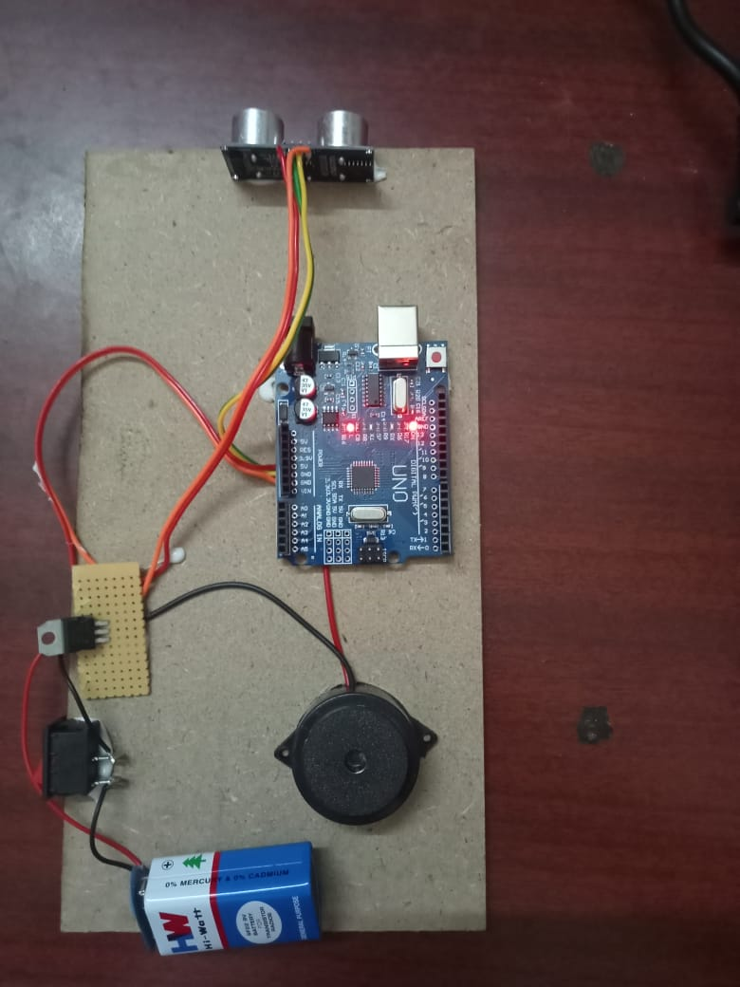
Figure No. 1 PROTOTYPE

- The drawing illustrates the complete hardware setup of the Train Accident Prevention System prototype. The model is mounted on a wooden base for stability. On the right side, an ultrasonic sensor (HC-SR04) is positioned facing outward to continuously detect obstacles on the track. The sensor is connected to the Arduino Uno microcontroller, which is placed at the center of the board and serves as the main processing unit. The Arduino is powered through external connections and displays status using its on-board LEDs.
- On the left side, a 9V battery supplies power to the overall circuit through a switch and a small regulator board. A buzzer is mounted next to the battery, which acts as the warning device. When the sensor detects an obstacle within the critical range, the microcontroller activates the buzzer to alert the user. All components are interconnected using jumper wires to form a compact and functional safety detection system.

BLOCK DIAGRAM

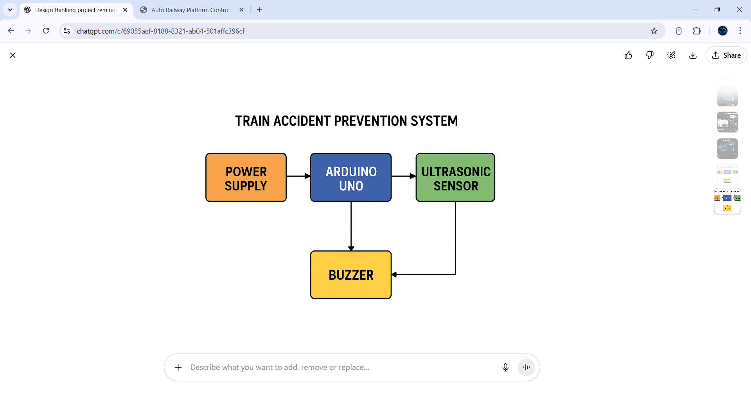
Figure No. 2 Block diagram

- POWER SUPPLY – Provides Electrical Energy
- The power supply block delivers the necessary voltage to operate all components of the system. It ensures that the Arduino, ultrasonic sensor, and buzzer receive stable and continuous power for accurate functioning. Without this block, the system cannot run or sense any obstacles.

- ARDUINO UNO – Central Processing Unit
- Arduino Uno acts as the brain of the entire system.
Its functions:
- Receives power from the power supply
- Collects distance data from the ultrasonic sensor
- Processes the distance values
- Checks whether the obstacle is in the danger zone
- Controls the buzzer based on the situation
- It is responsible for making real-time decisions to prevent accidents.

- ULTRASONIC SENSOR – Detects Obstacles
- The ultrasonic sensor continuously monitors the railway track.
Its functions:
- Sends ultrasonic waves forward
- Receives the waves reflected from an object
- Calculates the distance to the obstacle
- Sends the distance data to the Arduino
- This sensor is the main detection component that identifies obstacles such as animals, vehicles, or objects on the track.

- BUZZER – Gives Warning Alert
- The buzzer acts as the warning output device.
Its functions:
- Produces a loud sound when activated
- Alerts the train driver immediately
- Helps the driver take timely action
- Prevents collisions by providing early warning
- The buzzer turns ON only when the Arduino detects a dangerous obstacle distance.

Claims I/We Claim,
1.The system detects railway track obstacles using an ultrasonic sensor that continuously scans the path ahead.
It sends out ultrasonic waves and measures the reflected signal to calculate distance.
Whenever an object enters the danger zone, the sensor immediately sends data to the controller.
This ensures the system works automatically without depending on human eyesight.
It helps identify obstacles such as animals, vehicles, or objects on the track in real time.
2.The Arduino Uno microcontroller processes all incoming sensor signals and calculates the safety status instantly.
It compares the detected distance with a predefined threshold to determine danger.
If the distance is unsafe, the Arduino triggers the warning mechanism without delay.
This real-time processing ensures fast response during emergencies.
It acts as the intelligent control unit that manages decision making.
3.The system includes an automatic buzzer alert to warn the driver when danger is detected.
Once activated, the buzzer produces a loud sound that immediately grabs attention.
This early warning gives the driver enough reaction time to slow down or stop the train.
The alert works even in noisy or low-visibility environments.
It forms a crucial safety link between detection and prevention.
4.The entire system is powered by a stable power supply to ensure continuous monitoring at all times.
It provides the required voltage to the Arduino, sensor, and buzzer.
This ensures that the system remains active even during long-duration operation.
A consistent power source prevents failures that could lead to missed detections.
It keeps the system reliable and functional under different working conditions.
5.The invention is designed to be low-cost, simple, and easy to implement using basic electronic components.
Despite its simplicity, it performs real-time monitoring with high efficiency.
It can be installed on small-scale models and extended to real railway systems.
The design eliminates the need for expensive cameras or complex communication units.
This makes the solution practical, scalable, and suitable for developing railway safety environments.

Signature of Applicants:

Dr.C.NANDAGOPAL | S.PRATHIBA | M.PREETHI | S.PRIYANKA

ABSTRACT

- Railway accidents remain a major safety concern due to obstacles, human error, poor visibility, and lack of real-time warning systems. To address this issue, the Train Accident Prevention System is designed as a smart, automated, and low-cost solution that can detect track obstructions before a collision occurs. The system uses an ultrasonic sensor to continuously scan the track by transmitting and receiving sound waves.
- The measured distance is processed by an Arduino Uno microcontroller, which evaluates whether the detected object falls within a critical danger zone. When an obstacle is identified, the system instantly activates a buzzer that serves as an audible alert for the train driver, ensuring immediate response and timely prevention of accidents.
- The use of ultrasonic sensing technology allows the system to function effectively even in challenging conditions such as night, fog, or curves where visual detection is limited.
- Built with affordable and easy-to-implement components, the model demonstrates high efficiency, reliability, and quick reaction time. By integrating real-time detection with automatic alert generation, this project provides a practical approach to enhancing railway safety, reducing collisions, and supporting safer transportation infrastructure.

